Name: ---------------------------------------------- Date:------------------------
Year 11 Practice test on Atomic structure
Total mark = /13
Question 1

Isotopes of carbon are used to determine the age of fossilised organic samples dug up by archaeologists.

- Explain what is meant by the term isotope. (2 marks)

___________________________________________________________________________________________________________________________________________________________________________________________________________________________
- Explain why isotopes of the same element have the same chemical properties.
(2 marks)
_____________________________________________________________________________________________________________________________________________________________________________________________________________________________________________________________________________________________________________________________________________________________________________
- Calculate the mass, in grams, of a single atom of this isotope of carbon-12.
(2 marks)
______________________________________________________________________________________________________________________________________________________________________________________________________________________________________________________________________________________________________________________________________________________________________________________________________________________________________________________

Question 2

(a) Using labelled arrows, on the periodic table below clearly label the trends in electronegativity, first ionisation energy and atomic radius. (3 marks)

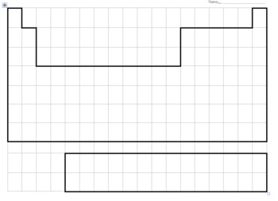

- Describe and explain the trends for atomic radius. (4 marks)
____________________________________________________________________________________________________________________________________________________________________________________________________________________________________________________________________________________________________________________________________________________________________________________________________________________________________________________________________________________________________________________________________________________________________________________________________________________________________________________________________________________________________________________________________________________________________________________________________________________________________________________________________________________________________________________________________________________________

